MyChart Mobile – Virtual Urgent Care
Patient selects Virtual Urgent Care to get started
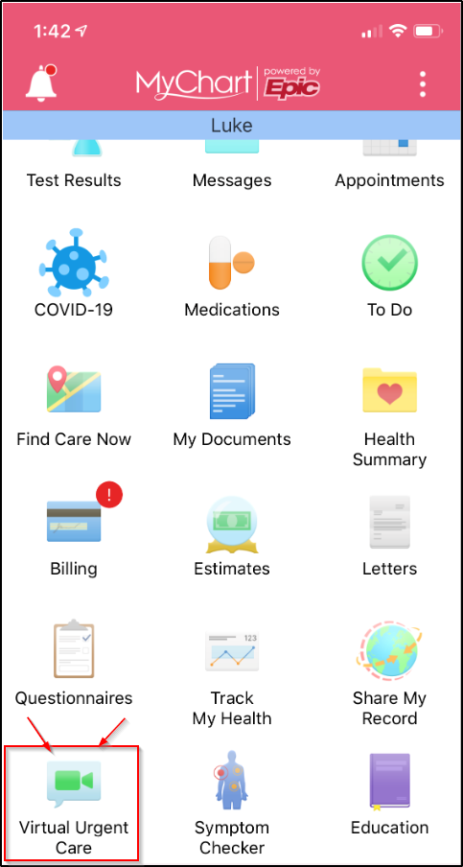

Patient confirms their location
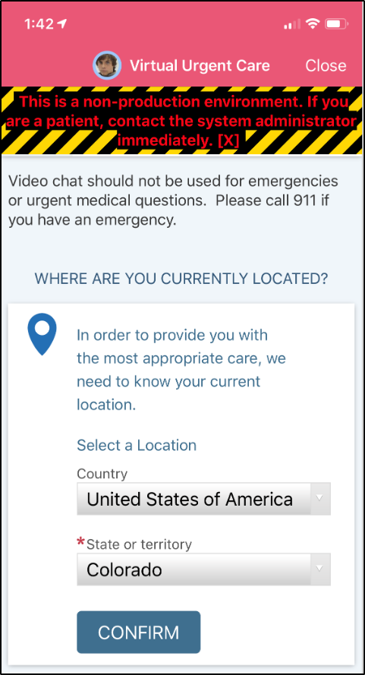

Patient selects a reason for visit
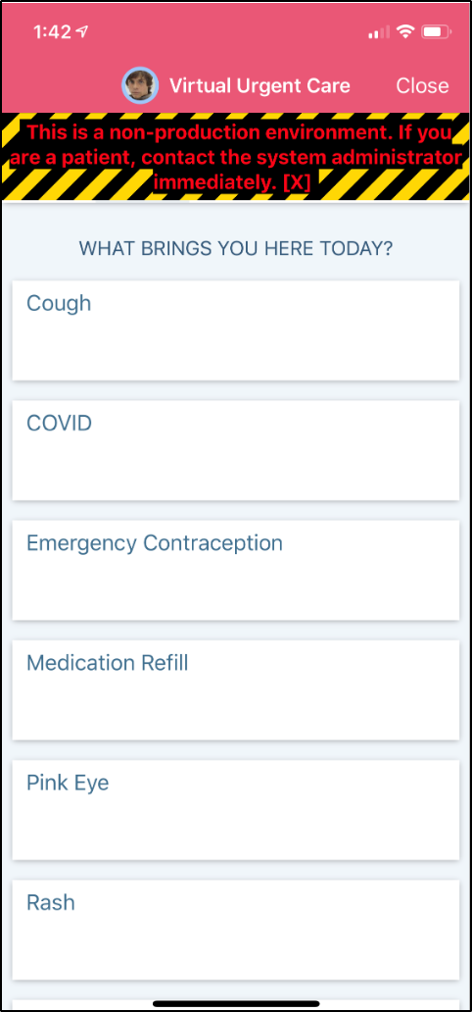

Patient can schedule the next available time or click More Times and choose one that works best for them
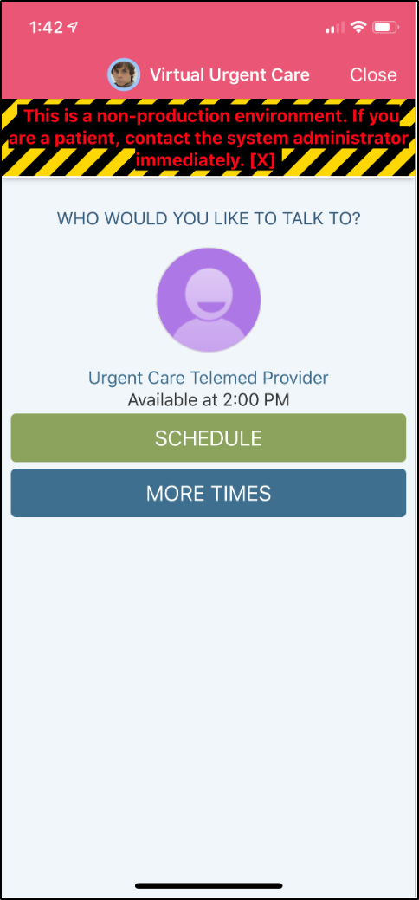 | 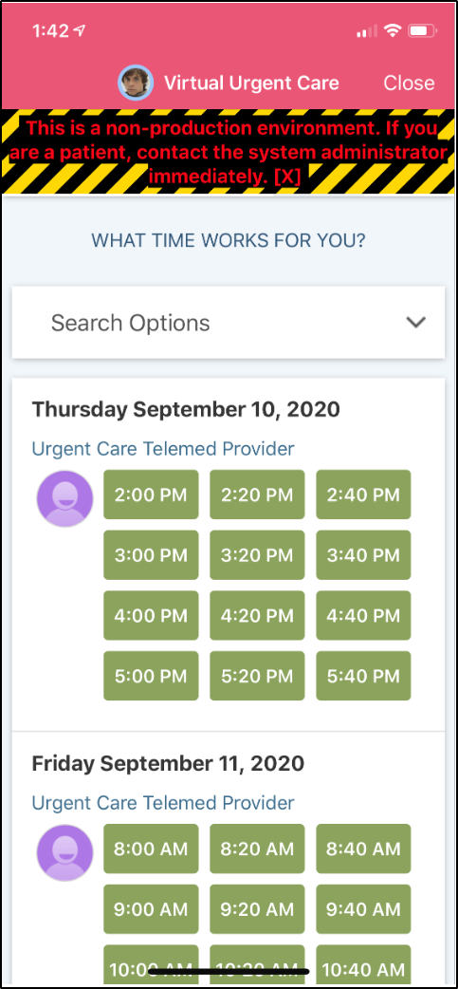

Patient can enter text about why they want to be seen and clicks Schedule
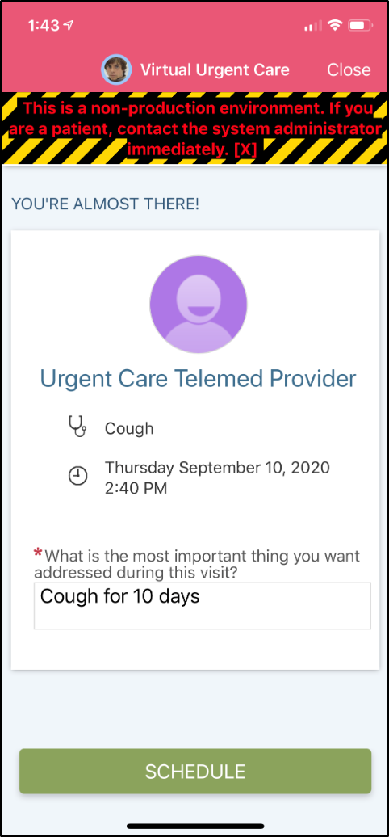

They are now presented with a confirmation screen
